Detailed Integration Report: Automated Resistivity Mapping System Using CPS-05 Four-Point Probe, FSK30J Linear Stage, Benbox Y20220304 Controller, Raspberry Pi/Arduino
This report provides complete specifications for each component (based on manufacturer data and standard references for these models) and a step-by-step guide to mechanically, electrically, and programmatically integrate them into a working system. The goal is an automated or semi-automated setup for four-point probe resistivity/sheet resistance measurements: the fixed CPS-05 probe contacts the sample, while the FSK30J linear stage advances the sample in precise steps (e.g., 1 mm increments) under the probe for mapping or profiling.
The Benbox board drives the stage's stepper motor. A Raspberry Pi (preferred for logging and flexibility) or Arduino orchestrates motion and data acquisition from the probe's electrical measurement circuit. This creates a low-cost scanning resistivity system.

1. Component Specifications
CPS-05 Four-Point Probe (Alessi / Cascade Microtech compatible)
- Type: Manual or mountable probe head using Cascade C4S head.
- Probe tips: Tungsten carbide (WC), spring-loaded (constant force, typically ~60–100 g per tip to avoid damaging thin films).
- Spacing: 1 mm between adjacent tips (standard for this model; outer-to-outer = 3 mm).
- Operation: Push-button lowers the four collinear probes onto the sample. Outer probes carry current (I); inner probes measure voltage (V).
- Measurement range: Compatible with typical setups (sheet resistance 0.1 mΩ/sq to MΩ/sq range, depending on your source/voltmeter).
- Connections: 4 independent wires (outer pair for current, inner pair for voltage; no built-in electronics—requires external source and meter).
- Use for resistivity: Standard four-point probe equations apply. For thin films (thickness t ≪ probe spacing s = 1 mm): Rs=πln⁡2⋅VI≈4.532⋅VI(Ω/□) R_s = \frac{\pi}{\ln 2} \cdot \frac{V}{I} \approx 4.532 \cdot \frac{V}{I} \quad (\Omega/\square) Rs​=ln2π​⋅IV​≈4.532⋅IV​(Ω/□) Bulk resistivity (thick samples, t ≫ s): ρ=2πs⋅VI \rho = 2\pi s \cdot \frac{V}{I} ρ=2πs⋅IV​ Then ρ=Rs⋅t \rho = R_s \cdot t ρ=Rs​⋅t for thin films. Typical test current: 0.1–10 mA (e.g., 4.53 mA so Rs R_s Rs​ in Ω/sq = V in mV).
- Notes: Mount fixed above the stage. No automation of probe lowering (manual button or add a simple solenoid later).
FSK30J Linear Screw Actuator (FUYU Technology)
- Type: Compact ball-screw linear stage (mute/low-noise version).
- Dimensions: ~30 mm width; height ~23.6 mm; overall length = stroke + ~100 mm ends.
- Stroke options: 50–500 mm (choose based on your sample size).
- Screw: Default Tr8×2 (8 mm diameter, 2 mm lead/rev); optional Tr8×4.
- Motor: Integrated NEMA14 bipolar stepper (35×35 mm frame, ~10–20 Ω/coil).
- Performance: Repeatability/position accuracy ±0.02–0.05 mm; max horizontal load ~3 kg (vertical ~2 kg); max speed ~40–200 mm/s (no load, depending on lead and driver). Noise <60 dB.
- Wiring: 4-wire stepper (colors vary—typically Black/Green/Red/Blue or similar). Use a multimeter to identify coil pairs (measure ~10–20 Ω between pairs; infinite between different coils).
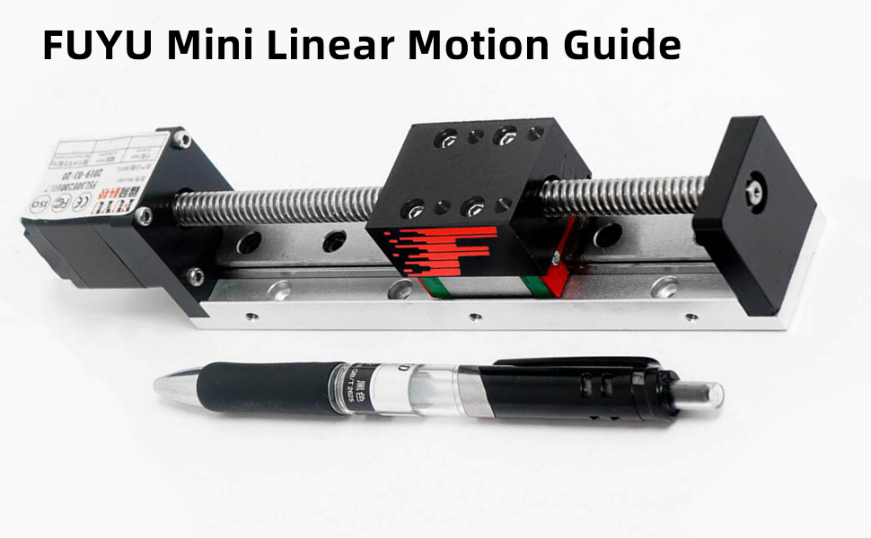
amazon.com
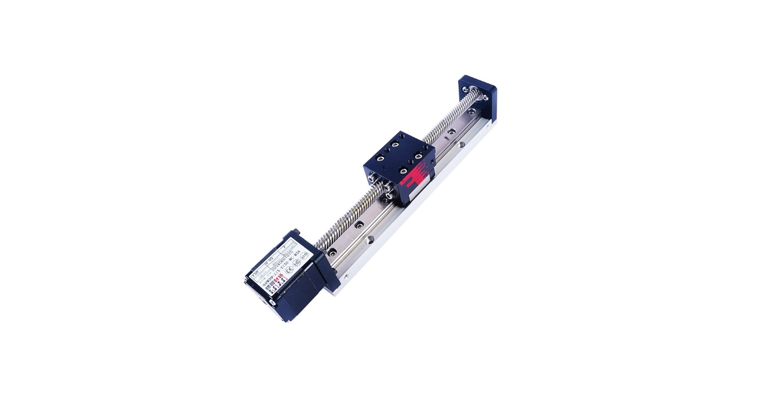
amazon.com
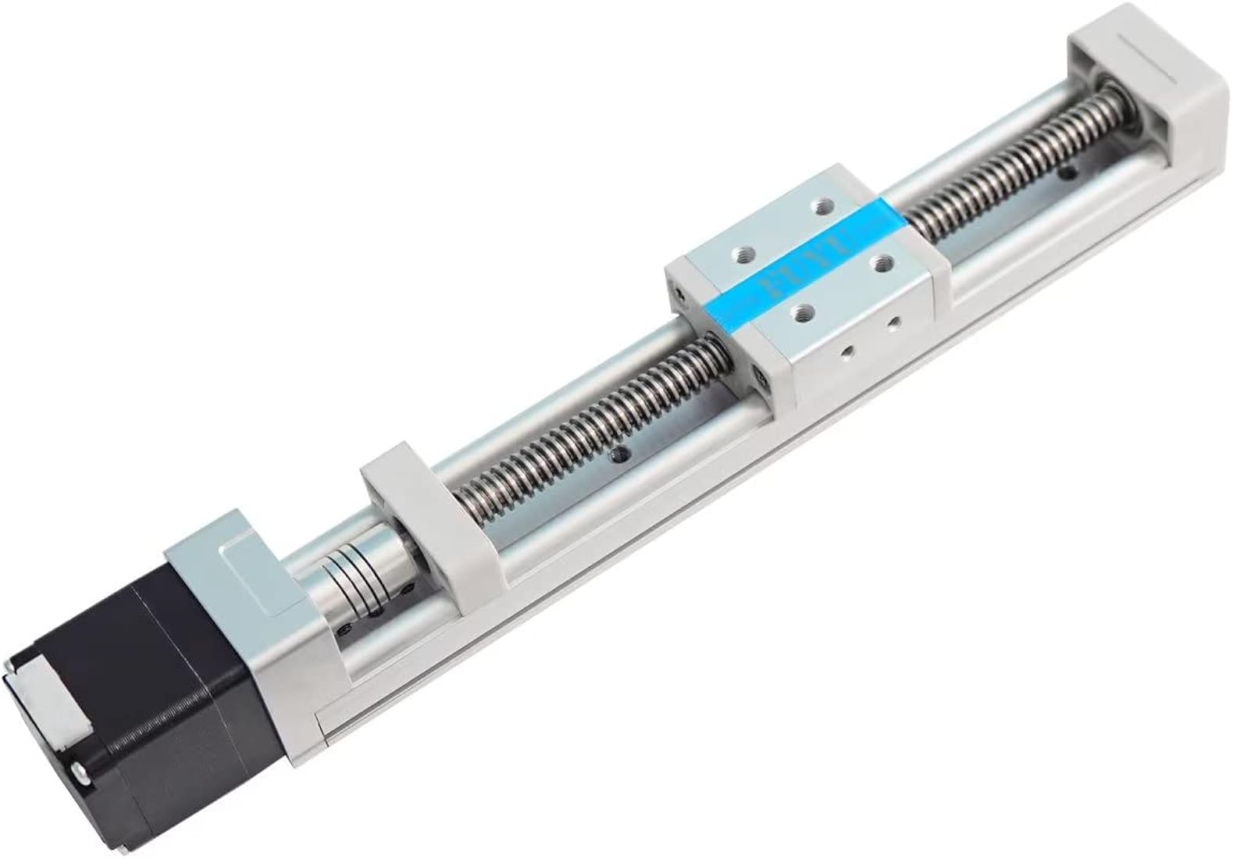
amazon.in
Benbox Y20220304 Controller Board
- Type: DIY laser/CNC controller (Arduino Nano clone + 2–3× A4988 or similar stepper drivers). Date code "Y20220304" is manufacturing stamp.
- Features: USB (CH340 chipset); 12–24 V DC power input; integrated microstepping (up to 1/16); X/Y1/Y2/Z motor outputs; laser PWM output (unused here); limit switch inputs.
- Firmware: Ships with Benbox-compatible; easily flash GRBL 1.1h (highly recommended for G-code control).
- Control: Accepts standard G-code (G0/G1 for positioning).
- Pinout highlights (key for your setup):
  - Motor connectors (4-pin each): Stepper outputs (A+, A–, B+, B– order varies—test or follow board silkscreen).
  - USB for serial control from Pi/Arduino/PC.
  - Power: DC 12–24 V (match your stepper voltage).
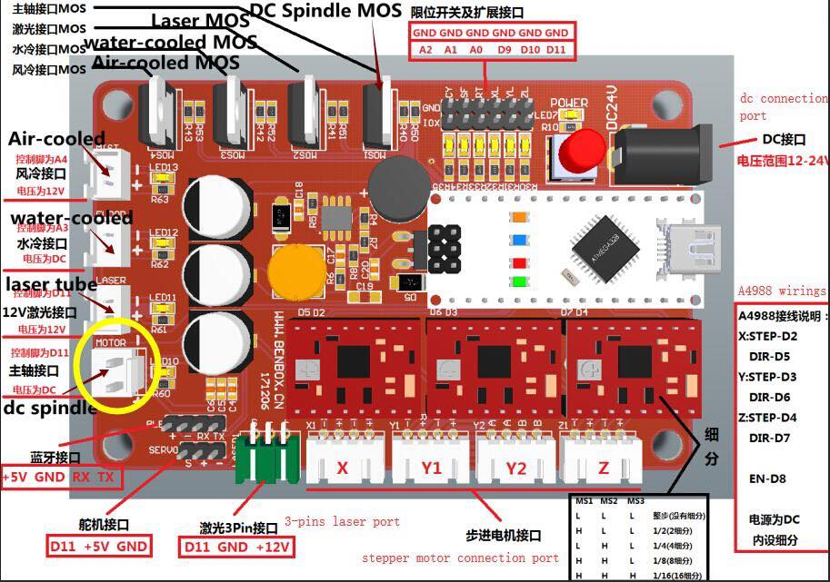
forum.lightburnsoftware.com
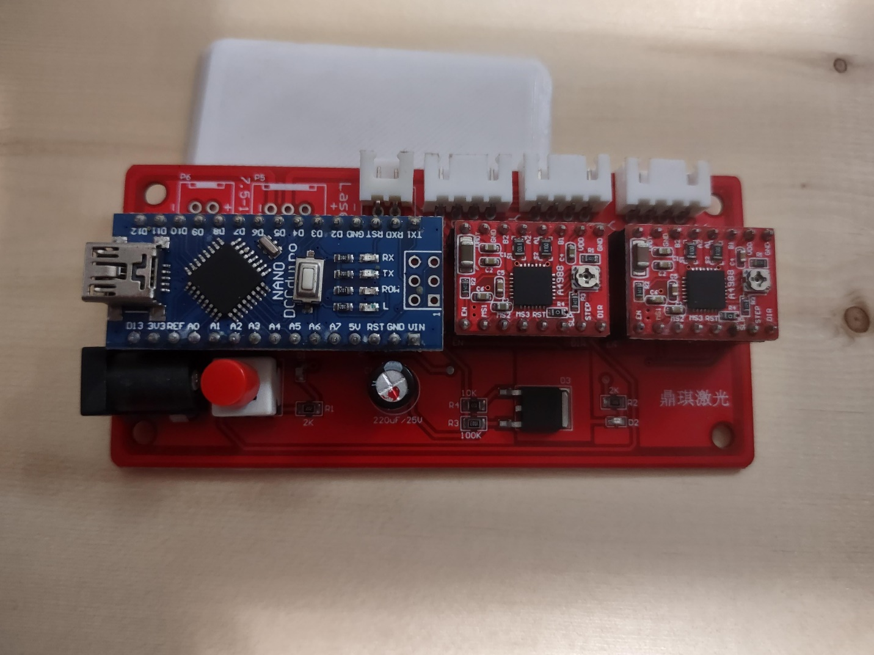
reddit.com
Raspberry Pi (or Arduino) for Data Acquisition & Control
- RPi (recommended): Any model (3/4/5) runs Python for full orchestration.
- Arduino (alternative/hybrid): Nano or Uno for simple ADC + motion if you skip the Benbox board.
- Role: Send G-code to Benbox via USB serial; read voltage/current from probe circuit; log data (CSV + position).

2. Mechanical Integration
- Mount the FSK30J stage securely on a flat base (aluminum plate or optical table).
- Attach a sample holder (non-conductive, e.g., 3D-printed or acrylic) to the carriage.
- Mount the CPS-05 probe head rigidly ~50–100 mm above the carriage (use aluminum bracket or lab stand). Align so probes land centered on the sample path.
- Adjust height so the spring-loaded probes contact properly when the button is pressed (or rig a fixed lowered position for automation).
- Add endstops (limit switches) to Benbox inputs for homing (optional but recommended).

3. Electrical Integration
Stepper Wiring (FSK30J → Benbox)
- Connect the 4 stepper wires to the X-axis motor connector on the Benbox board (use one axis only).
- Match coils: Identify pairs with multimeter, then plug in (swap A/B or +/– if direction is reversed—fix later in software).
- Power: 12–24 V DC supply to Benbox (at least 1–2 A).
Probe Measurement Circuit (CPS-05 → DAQ)
- Outer probes: Connect to a constant-current source (recommended: LM317 adjustable regulator or op-amp Howland pump set to 1–5 mA).
- Inner probes: Connect to a high-impedance voltmeter/ADC (Arduino analog pin or ADS1115 I2C module on RPi for 16-bit precision).
- Simple starter circuit: Use a fixed resistor + 5–12 V supply for approximate constant current; measure voltage drop across a sense resistor for exact I. Add series protection resistors and TVS diodes.
- Ground: Common ground between all systems (careful with noise—use separate analog/digital grounds).
Power Summary
- Benbox/FSK30J: 12–24 V DC.
- RPi: 5 V USB.
- Measurement: 5–12 V (separate if possible).

4. Software & Communication (How Everything Talks)
Recommended Setup: Raspberry Pi + GRBL on Benbox (USB serial link). The Pi sends motion commands and triggers measurements.
Step-by-Step Setup
- Flash GRBL 1.1h to the Benbox board (use Arduino IDE or XLoader tool; select Arduino Nano target).
- Calibrate steps/mm in GRBL (via serial terminal or LaserGRBL software first):
  - For Tr8×2 screw + 1/16 microstepping: $100=1600 (steps/mm for X-axis).
  - Set speed/accel: $110=1000 (mm/min), $120=100 (mm/s²).
- On Raspberry Pi: Install Python libraries (pip install pyserial pandas).
- Sample Python script skeleton (run on RPi):
Python
Copy
import serial
import time
import board # for ADS1115 or similar
# ... (initialize serial to Benbox /dev/ttyUSB0, baud 115200)
ser = serial.Serial('/dev/ttyUSB0', 115200)

def send_gcode(cmd):
ser.write((cmd + '\n').encode())
time.sleep(0.5) # wait for move

# Homing / move to start
send_gcode('G28') # or G0 X0
for pos in range(0, 100, 5): # steps in mm
send_gcode(f'G1 X{pos} F500')
time.sleep(1) # settle + manual probe contact if needed
# Read V from ADC (ADS1115 example) and known I
V = read_adc() # your ADC function
Rs = 4.532 * (V / I) # ohms/sq
print(f"Pos: {pos} mm | Rs: {Rs} Ω/sq")
# Log to CSV
- Arduino alternative: Use AccelStepper library directly on the Nano (bypass Benbox) + analogRead for voltage.
Data Flow
- RPi → USB serial → Benbox → Stepper pulses to FSK30J (precise positioning).
- Probe contacts sample → Current source drives outer probes → Voltage on inner probes → ADC/RPi reads → Calculate & log Rs/ρ with position.

5. Calibration, Testing & Safety
- Test motion first: Power Benbox, connect USB, use LaserGRBL or serial terminal to jog the stage.
- Calibrate steps: Move known distance, measure with calipers, adjust GRBL $100.
- Probe contact: Lower manually per measurement (or automate later).
- Current limits: Start ≤1 mA; monitor for heating (repeat measurements should be stable).
- Safety: ESD protection on samples; current-limited supply; mechanical limits to avoid crashing probe into stage.

6. Next Steps & Enhancements
- Build/test the current-source + ADC circuit (many open-source Arduino four-point probe sketches on GitHub).
- Add Z-axis or auto-contact later with extra stepper.
- Visualize data in Python (matplotlib) or export to Excel.
- Full mapping script can scan a grid if you add a second axis.
This integration turns your components into a functional automated resistivity profiler. Total build time: 1–2 weekends with basic soldering and 3D printing for mounts. If you provide photos of your exact boards/motor wire colors, probe terminals, or the measurement electronics you already have, I can refine wiring diagrams or provide exact code. Let me know how to proceed (e.g., full Python script, circuit schematic, or troubleshooting help)!

